Monday, October 12th
FB: Did the sweltering summer heat make you feel languid? Snow is just around the corner, which might call for some extra time spent under the covers. Synonyms for languid: lethargic, sleepy, unenergetic. Antonyms: vigorous, robust, energetic. #SATword

TW: Languid: the acceptable mood for winters in the northeast. #SATword

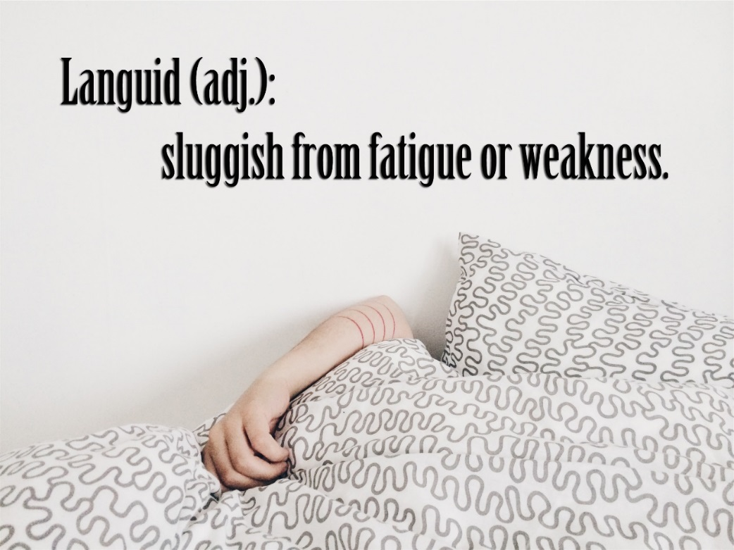

Wednesday, October 14th
FB: Children are using technology at very young ages. North Coast offers tips and information on how to keep your kids safe online, no matter what age. Check out our blog for the rest of our Online Safety series or contact us at info@northcoasted.com for more information. http://www.northcoasted.com/blog/?p=1365

TW: Children are learning how to use the internet as early as preschool. Let NCES show you how to keep them safe. http://www.northcoasted.com/blog/?p=1365

Friday, October 16th
FB: Is your child still unsure about how to dress up for Halloween? Try these creative DIY educational costume ideas, and let your child be a different sort of superhero. http://www.learningliftoff.com/15-diy-halloween-costumes-for-kids-with-an-educational-twist/#.VhMdLnpVikp

TW: What do Albert Einstein, Amelia Eirhart, and Van Gogh have in common? They’re awesome educational costume ideas! http://www.learningliftoff.com/15-diy-halloween-costumes-for-kids-with-an-educational-twist/#.VhMdLnpVikp

Monday, October 19th
FB: Ask any parent, and they’ll tell you that childhood is ephemeral. Children go from taking their first steps to graduating, and parents are left to wonder where the time went. Synonyms for ephemeral: fleeting, transient, momentary. Antonyms: lasting, permanent. #SATword

TW: Childhood, fashion trends, the bloom on a flower. These things are all ephemeral. #SATword

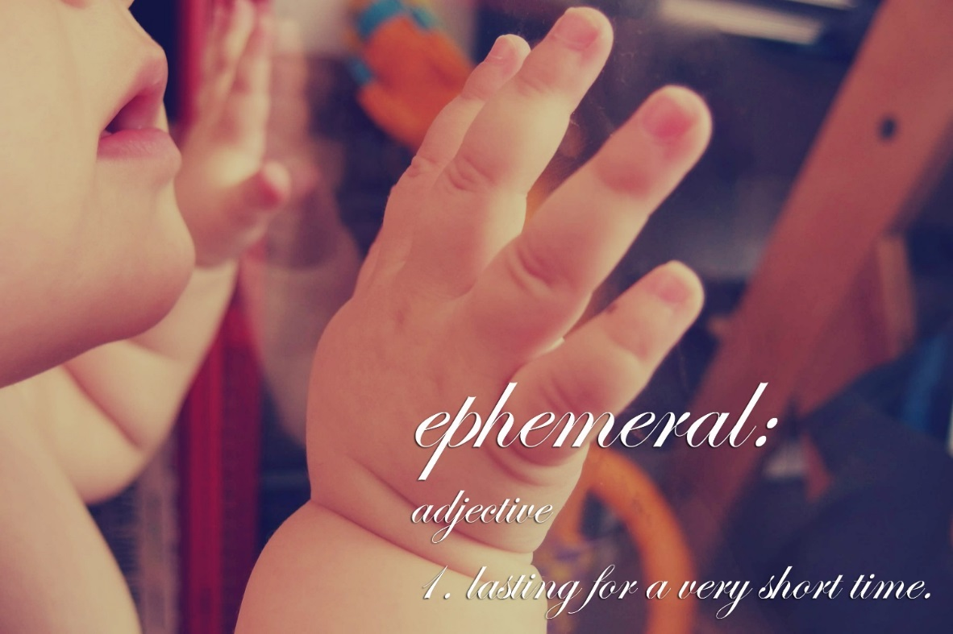

Wednesday, October 21st
FB: Homework, or no homework? That is the question that’s been plaguing school systems, children, and parents for years, but it might not be the right question to ask. Here’s an article discussing both points, and what parents can do to help their children retain what they’ve learned after class lets out. If your child is struggling with homework, reach out to North Coast at 440-914-0200 for in-home tutoring and other extracurricular help.
http://www.edutopia.org/blog/homework-vs-no-homework-wrong-question-maurice-elias

TW: If your child is overloaded and struggling, contact NCES today for in-home tutoring. http://www.edutopia.org/blog/homework-vs-no-homework-wrong-question-maurice-elias

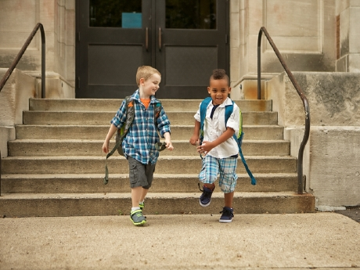

Friday, October 23rd
FB: Social media is undoubtedly changing the way children learn and interact, but how is it impacting education? At the college level, many lecturers, professors, and teachers are using social media to drive understanding and comprehension. See more here: http://www.bbcactive.com/BBCActiveIdeasandResources/Howsocialmediaischangingeducation.aspx

TW: How much does the twittersphere impact education? More than we might realize. http://www.bbcactive.com/BBCActiveIdeasandResources/Howsocialmediaischangingeducation.aspx

Monday, October 26th
FB: Just in time for Halloween! You see a shadow moving out of the corner of your eye, but when you turn your head, it’s gone. Was it the cat? Was it a trick of the light? Or was it a phantasm? #SATword

TW: What goes bump in the night? It’s nothing but a phantasm. #SATword

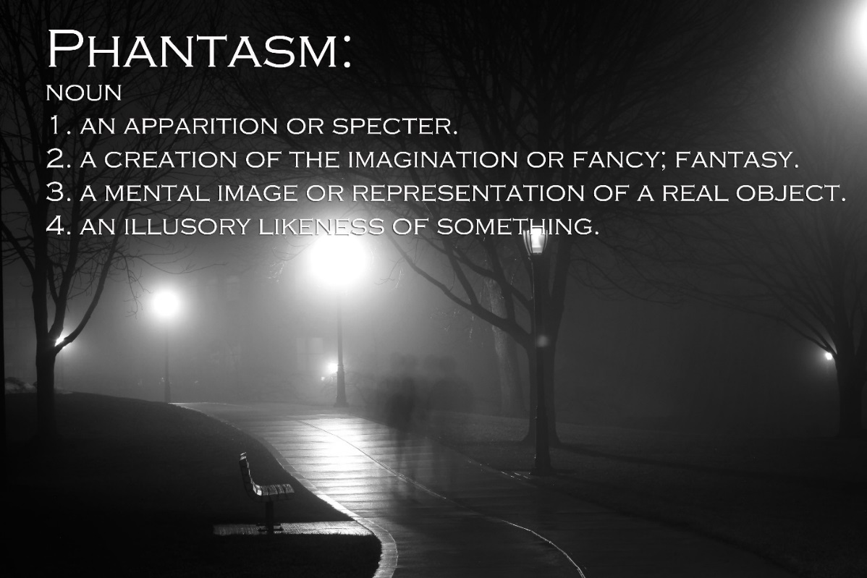

Wednesday, October 28th
FB: The time is almost here for the first round of parent-teacher conferences, if they haven’t happened already. The best types of conferences occur when the teacher and parents are collaborating for the success of the student. This article outlines the steps teachers and parents should take to have successful conferences.
http://www.edutopia.org/blog/parent-teacher-conferences-collaborative-conversations-john-mccarthy

TW: When parents and teachers collaborate during conferences and throughout the year, the student prospers.
http://www.edutopia.org/blog/parent-teacher-conferences-collaborative-conversations-john-mccarthy

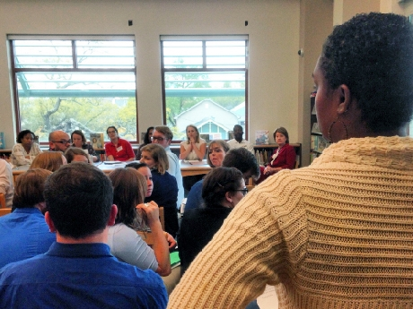

Friday, October 30th
FB: There are plenty of ways to make Halloween a time for education as well as celebration. Use these fun tricks and tips to incorporate Math into your child’s Halloween treats. http://www.whizz.com/en-us/2011/10/31/10-ideas-math-halloween-fun/

TW: Trick or Treat! Make math a part of your child’s Halloween with these simple games. http://www.whizz.com/en-us/2011/10/31/10-ideas-math-halloween-fun/

